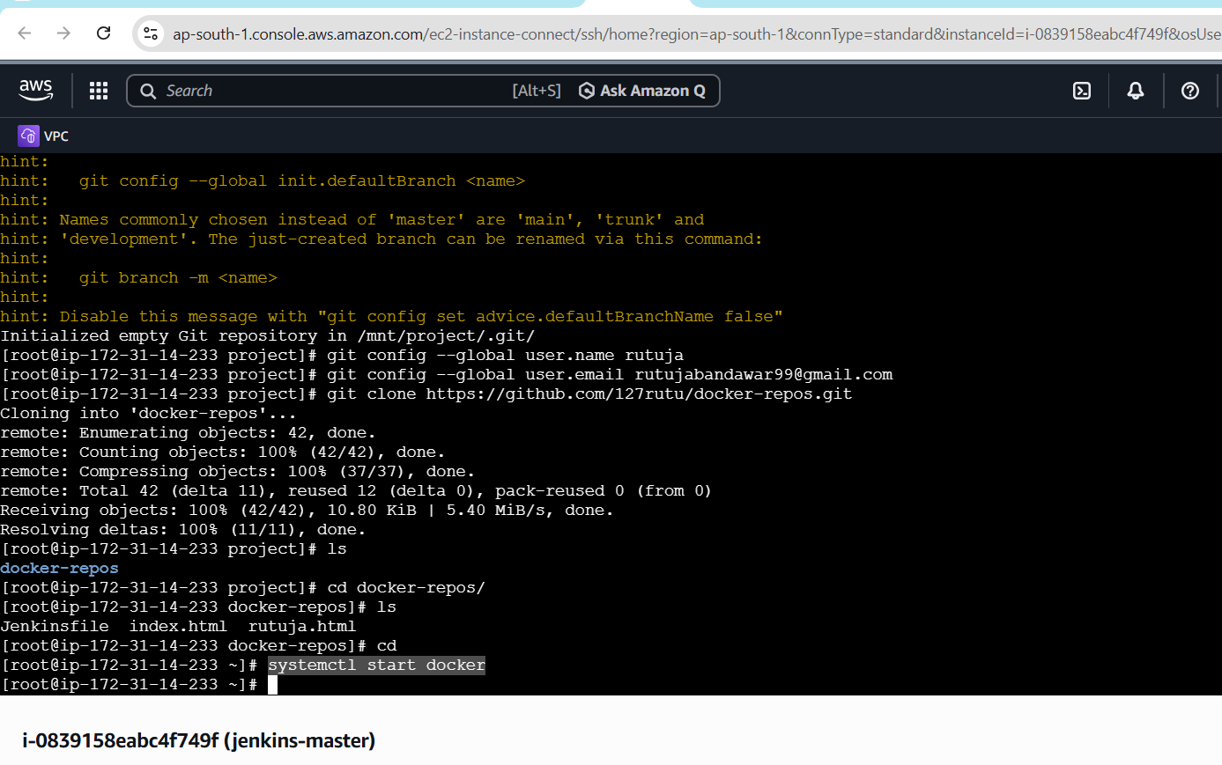
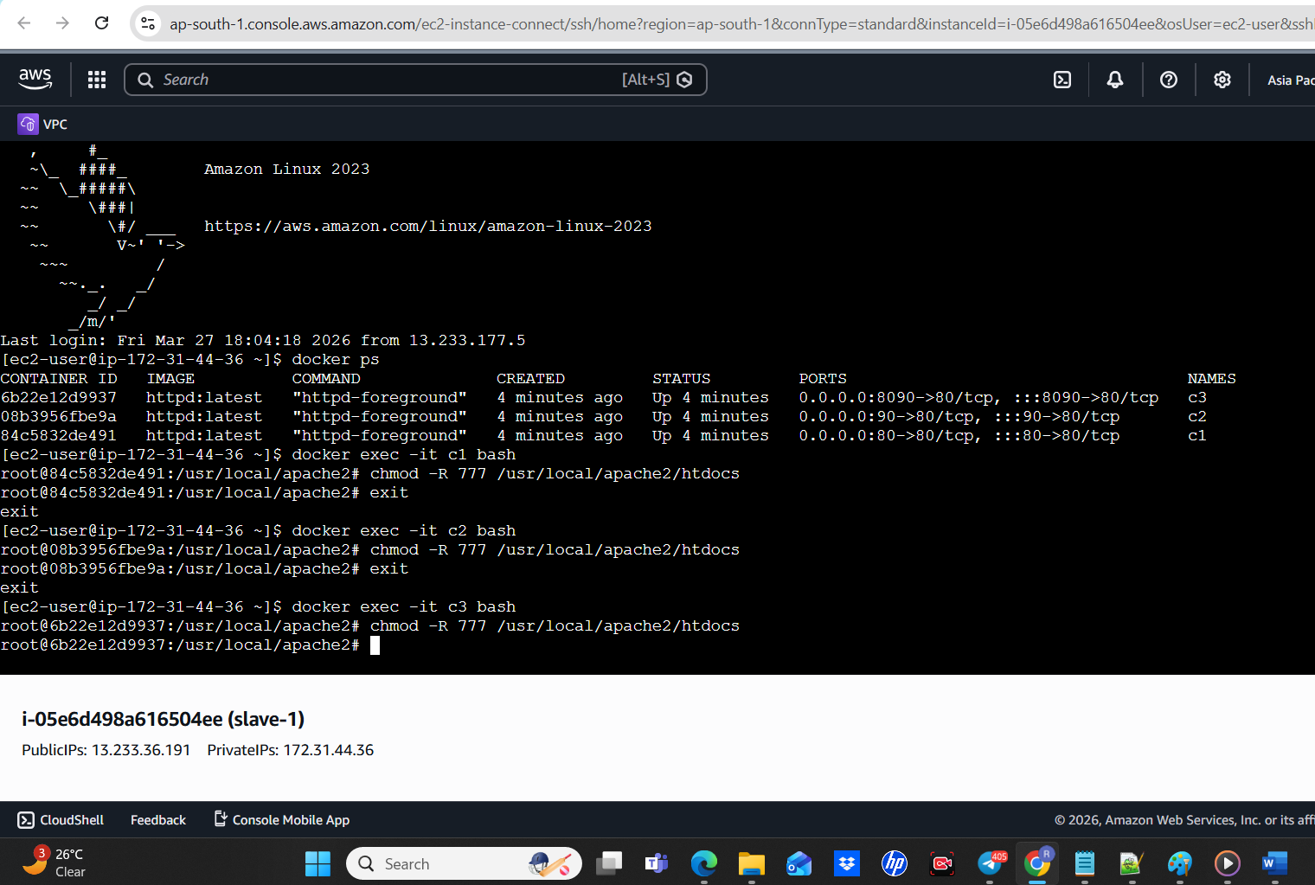
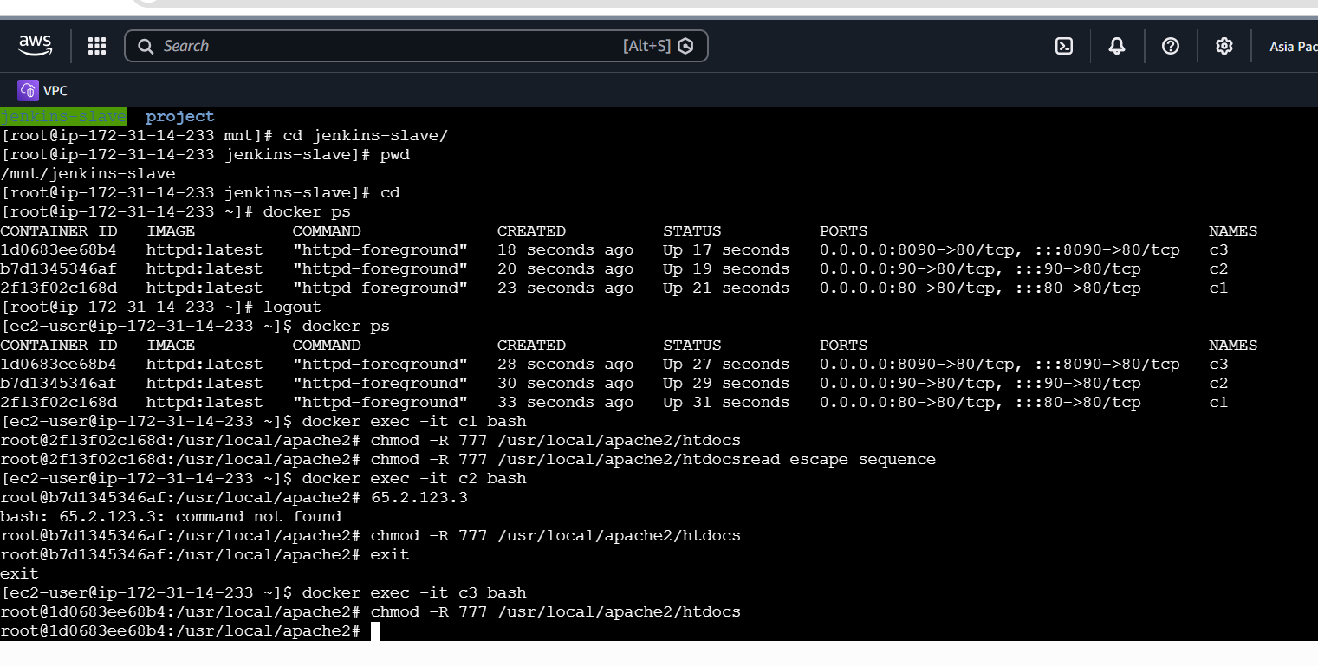
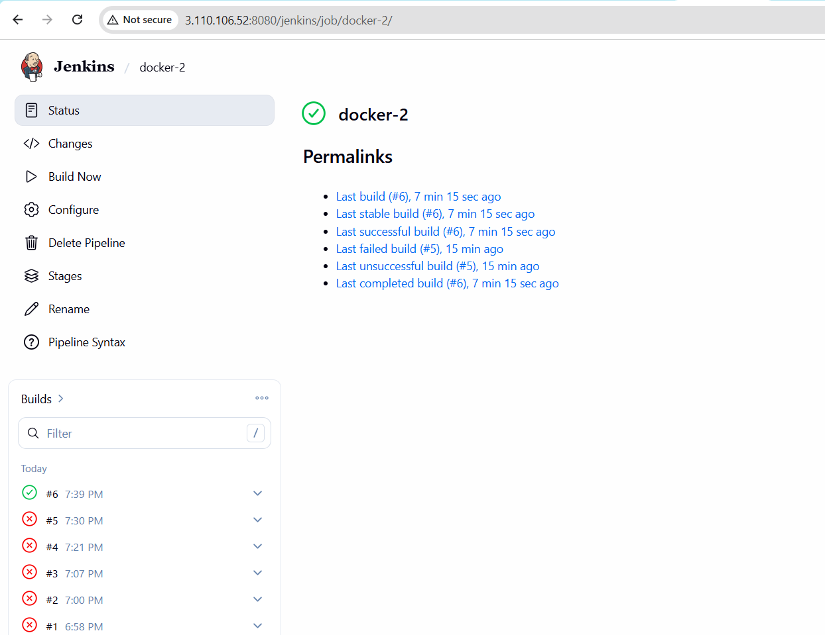
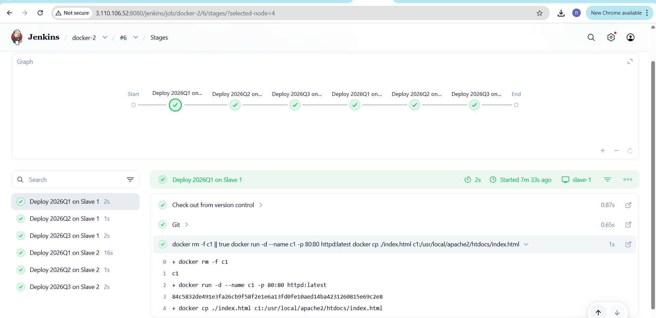
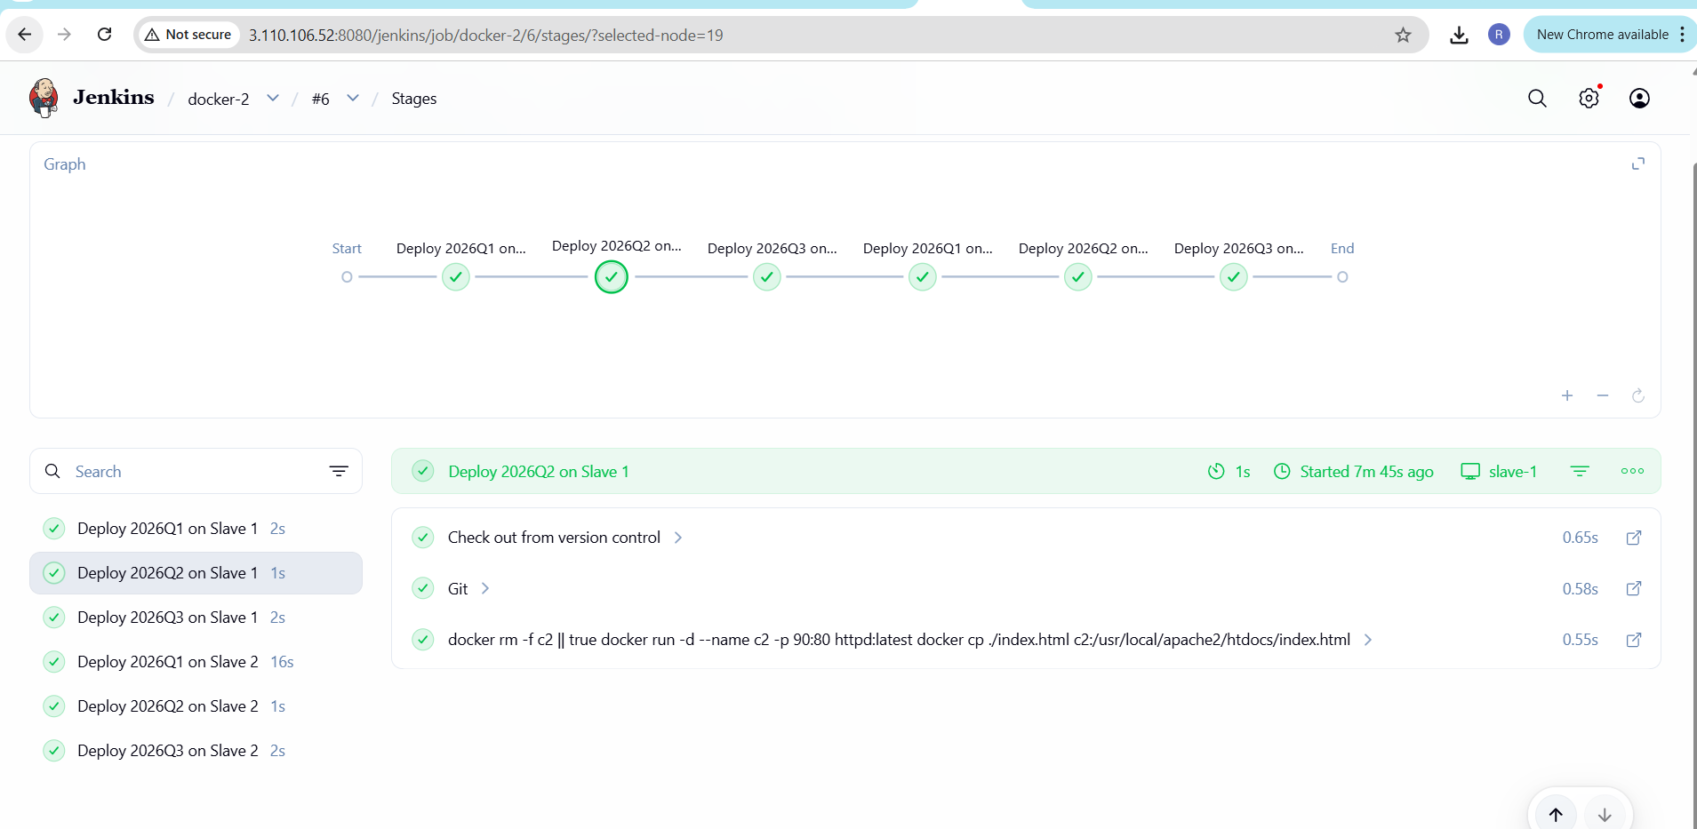
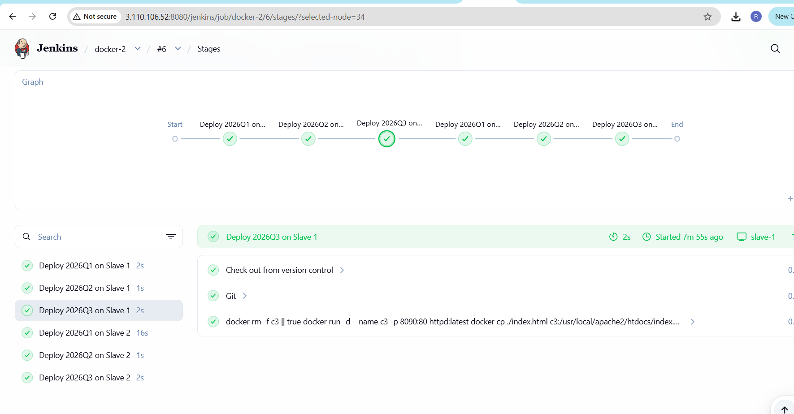
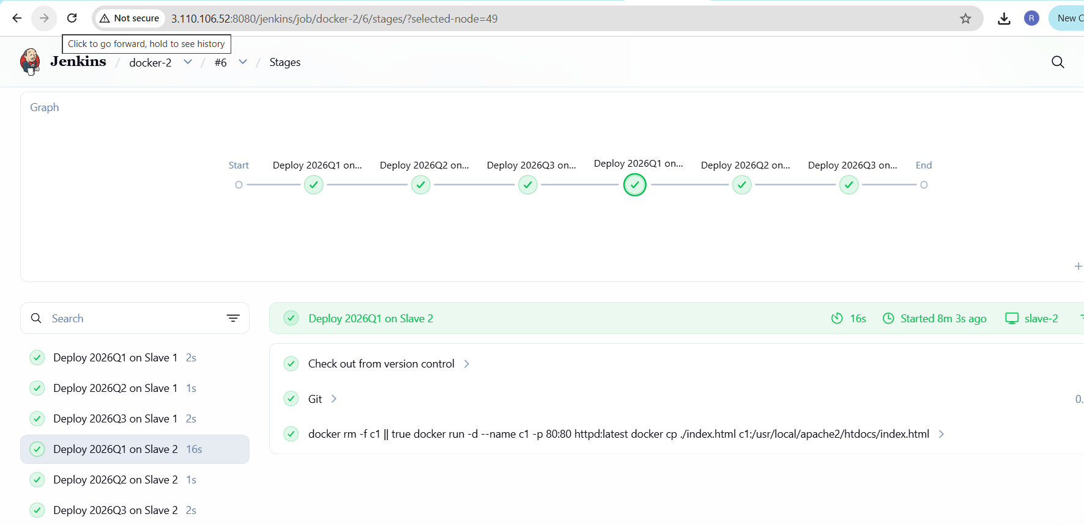
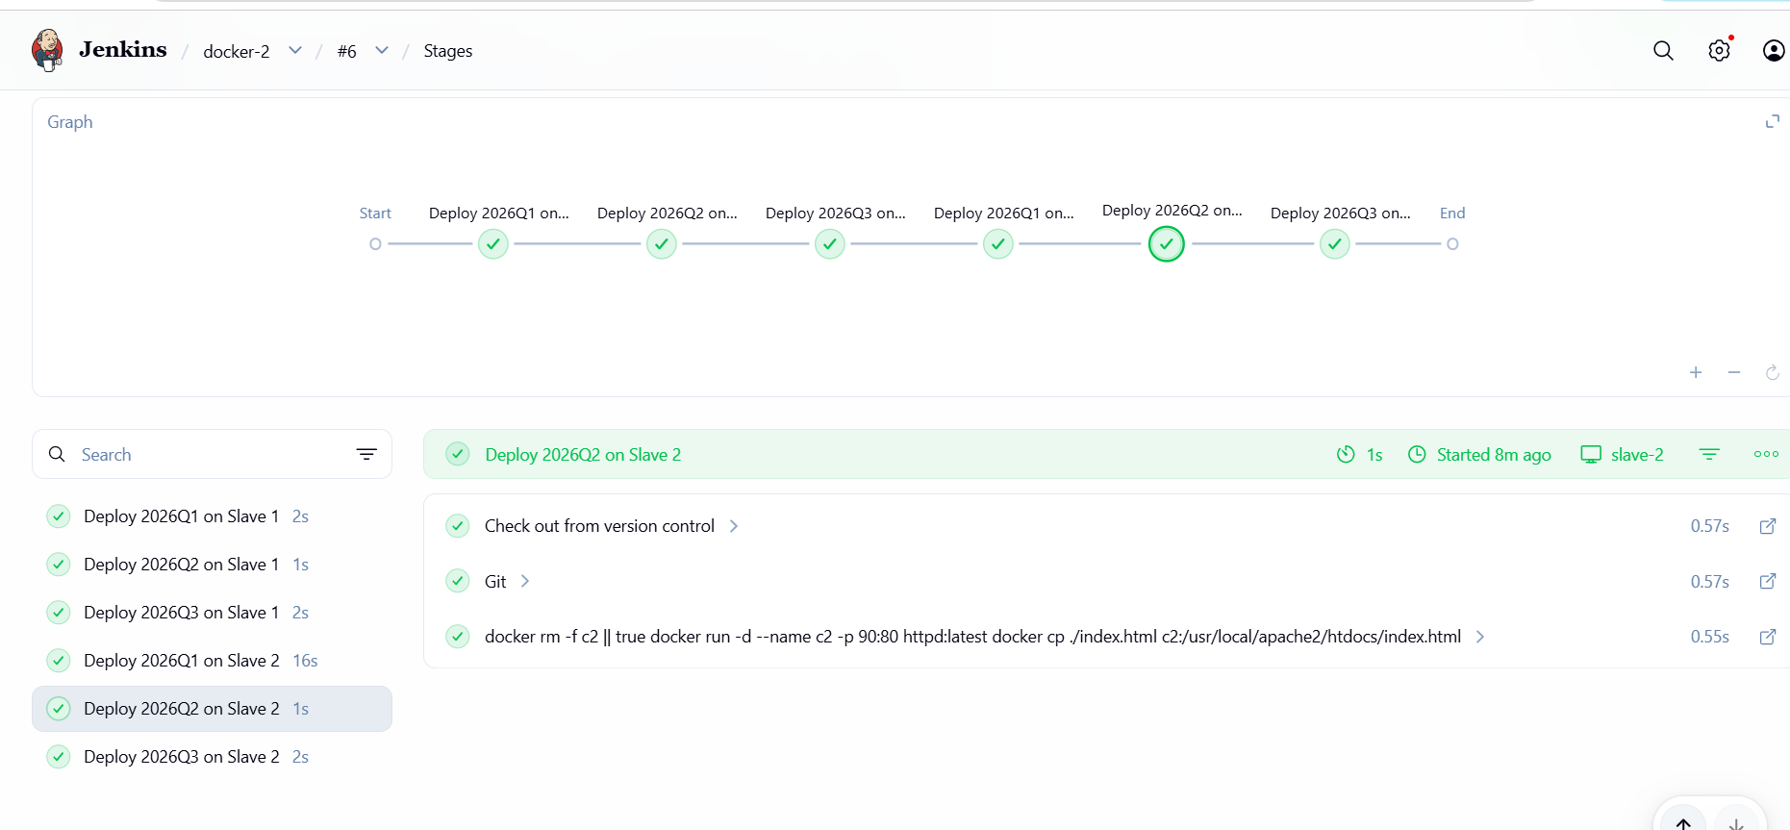
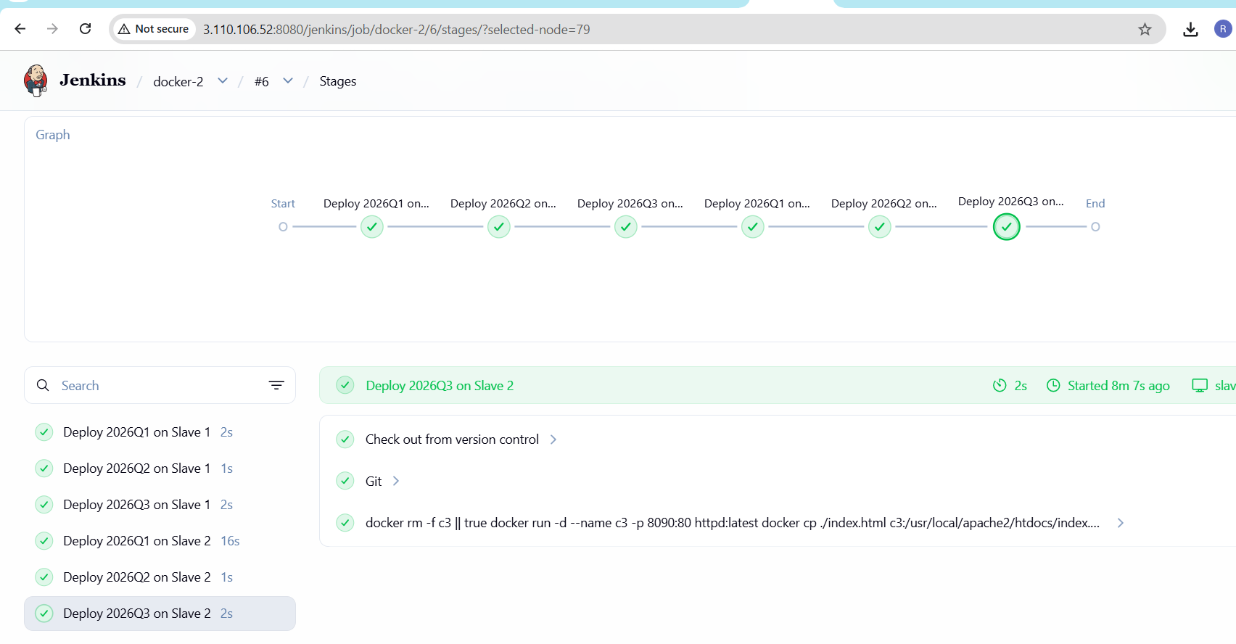
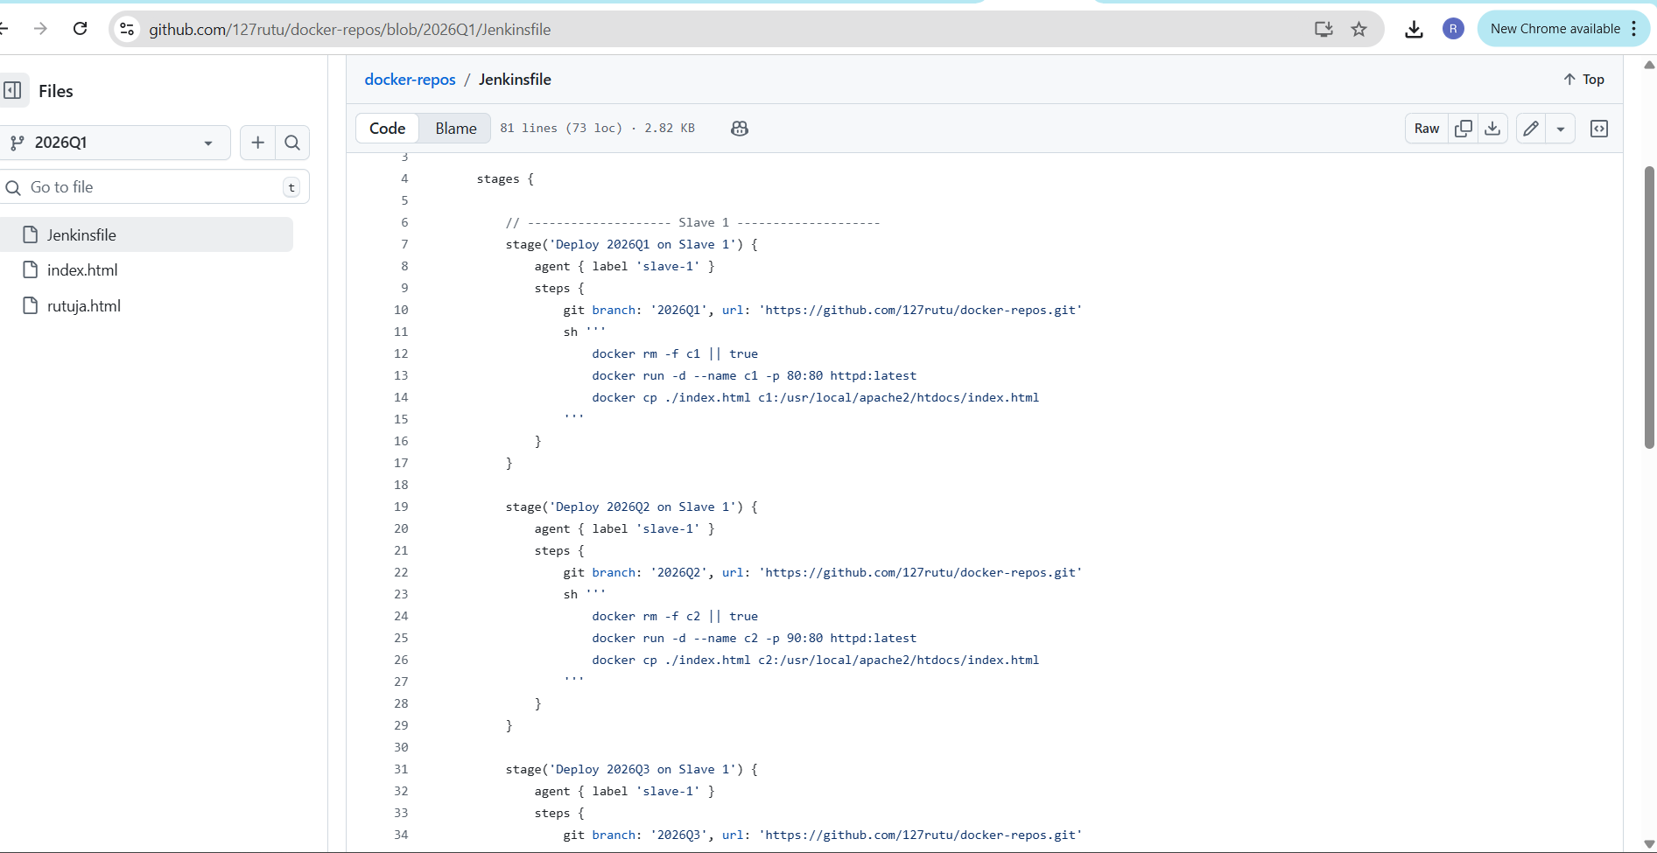
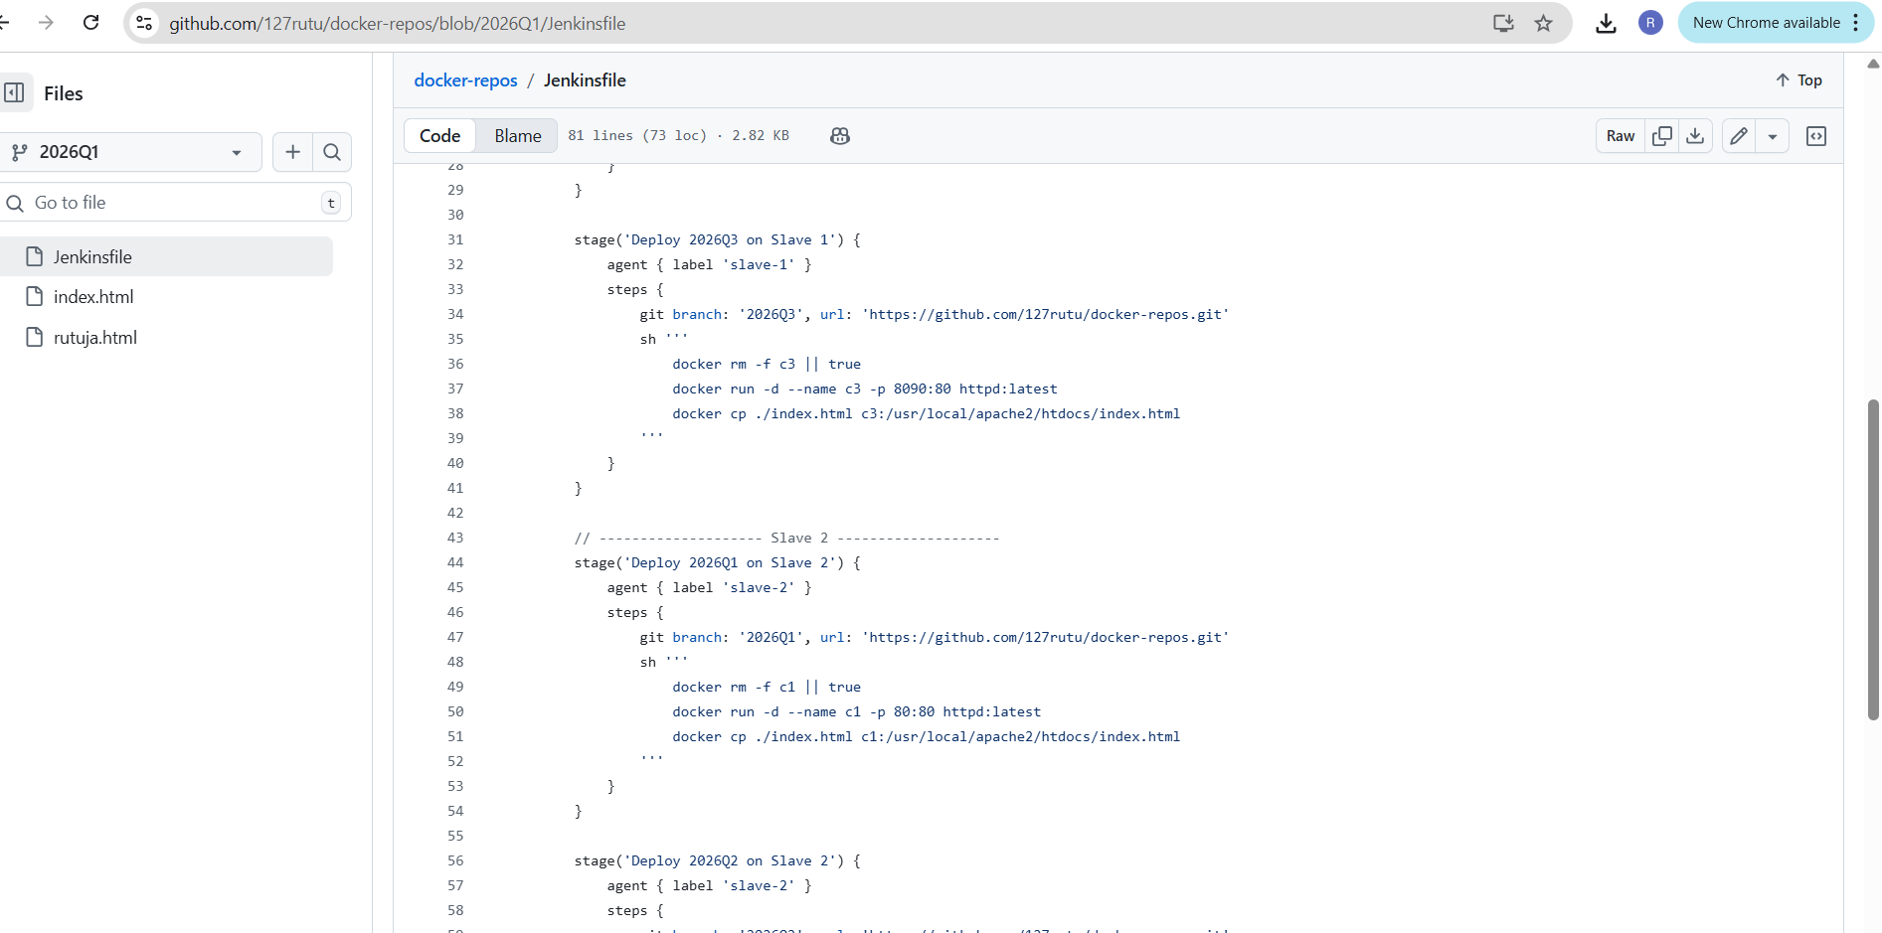
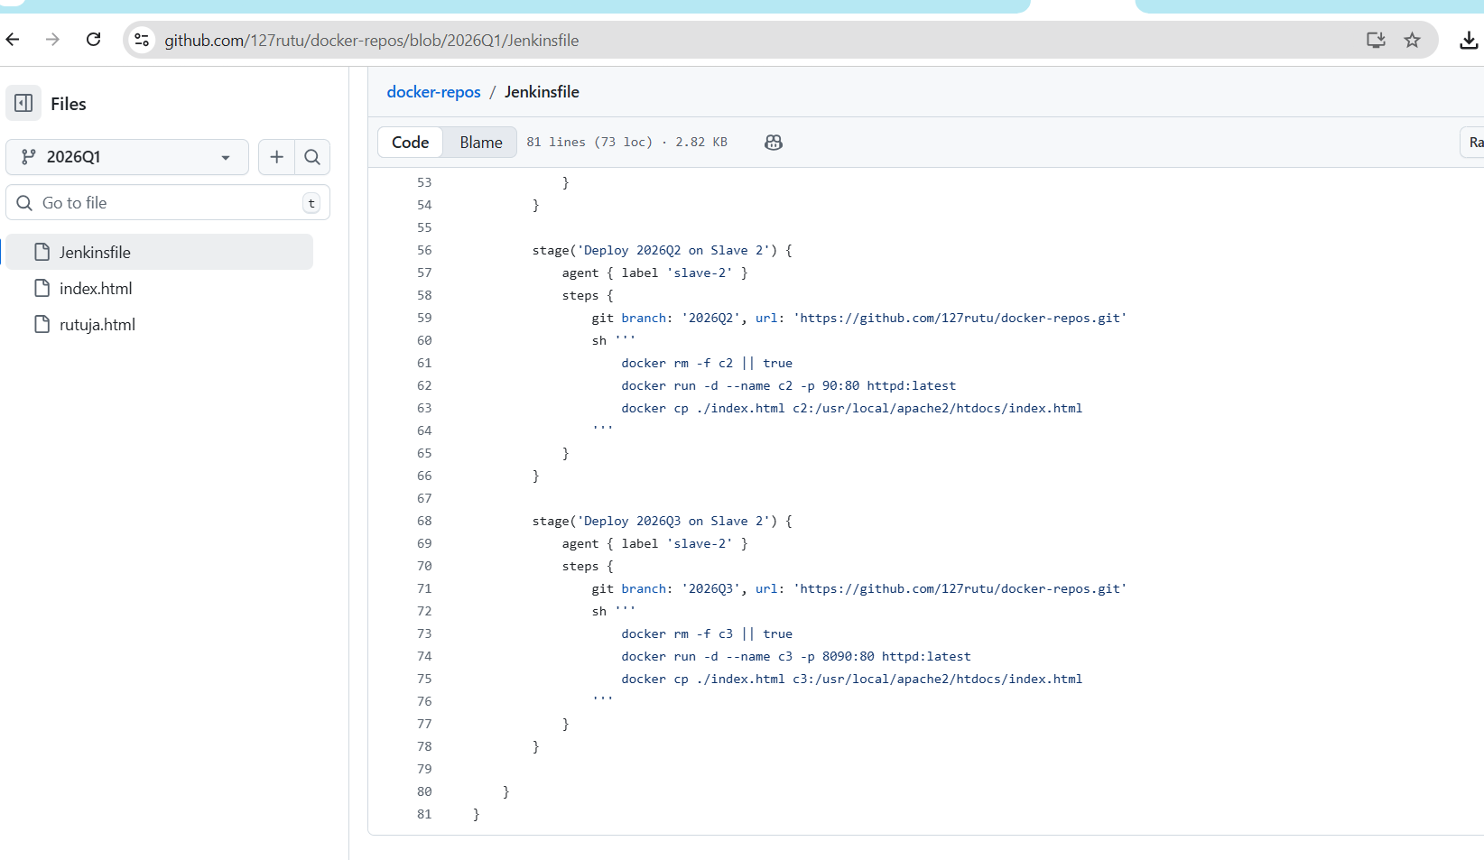
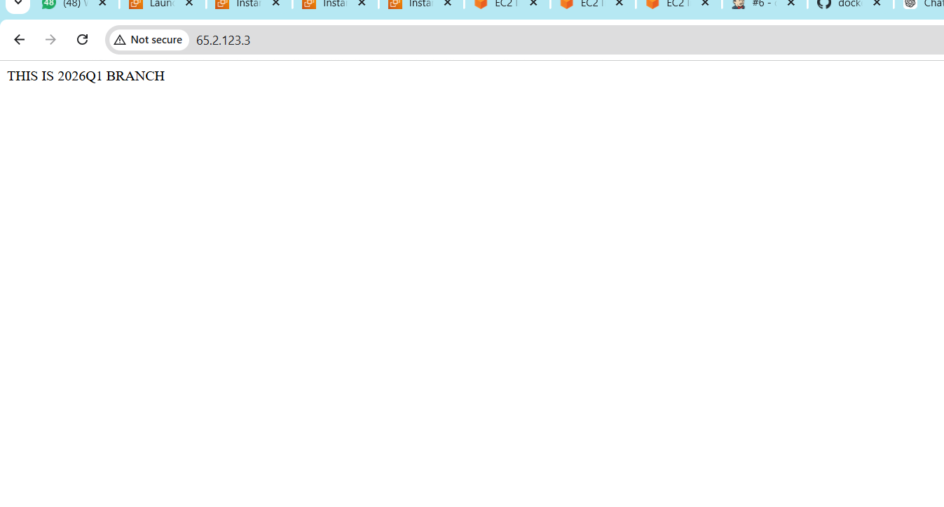
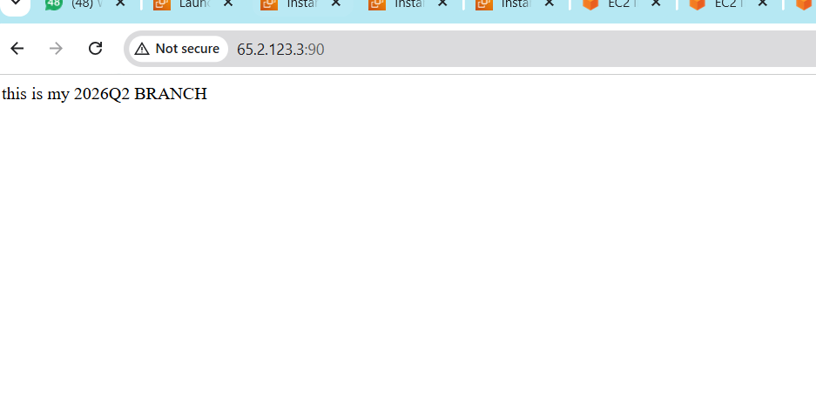
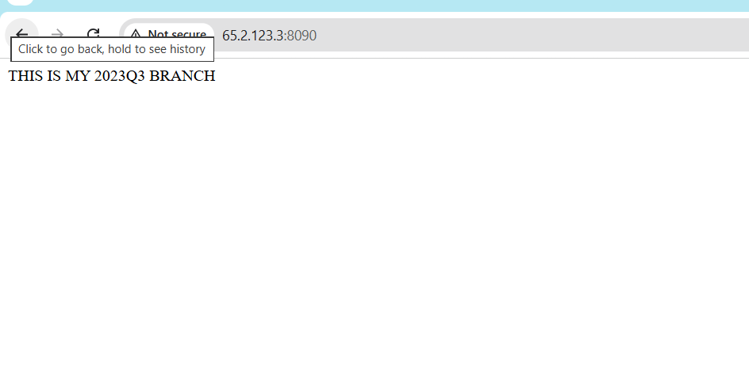
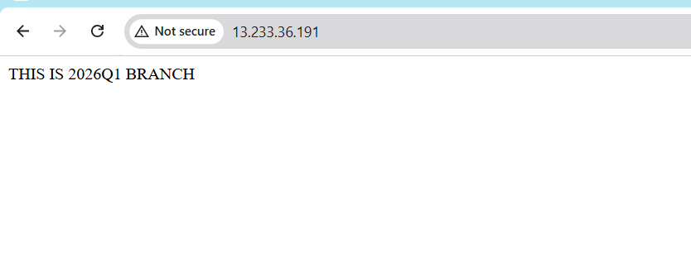
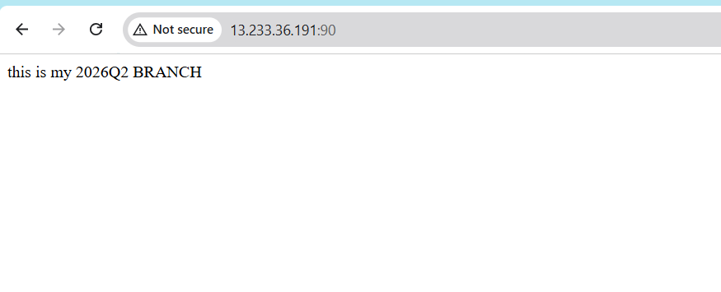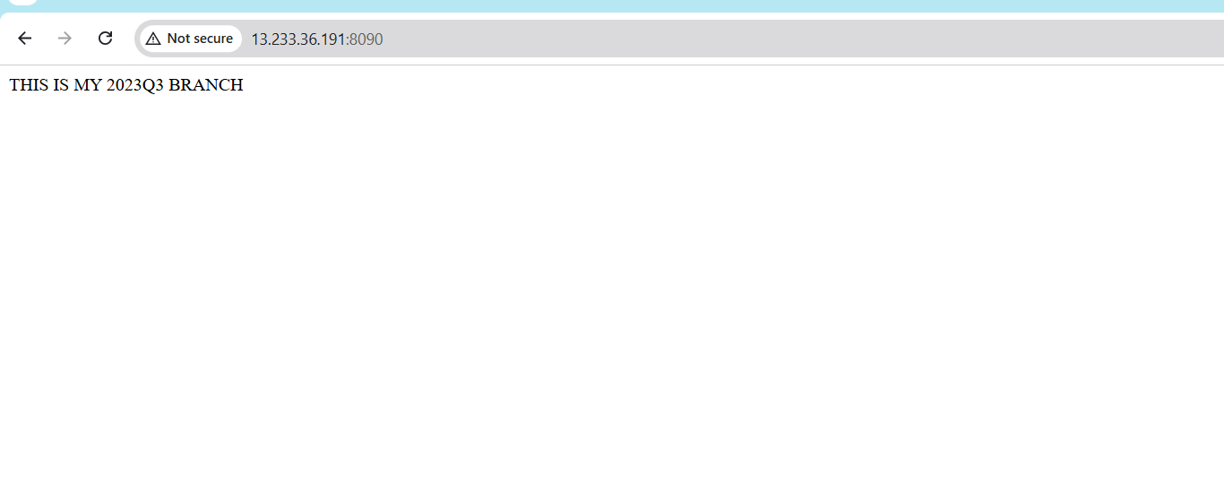
Here for slave there was no permission to run docker command
so I did
Added ec2 user in docker group
sudo usermod -aG docker ec2-user
su - ec2-user
docker ps
groups ec2-user

pipeline {
agent none

stages {

// -------------------- Slave 1 --------------------
stage('Deploy 2026Q1 on Slave 1') {
agent { label 'slave-1' }
steps {
git branch: '2026Q1', url: 'https://github.com/127rutu/docker-repos.git'
sh '''
docker rm -f c1 || true
docker run -d --name c1 -p 80:80 httpd:latest
docker cp ./index.html c1:/usr/local/apache2/htdocs/index.html
'''
}
}

stage('Deploy 2026Q2 on Slave 1') {
agent { label 'slave-1' }
steps {
git branch: '2026Q2', url: 'https://github.com/127rutu/docker-repos.git'
sh '''
docker rm -f c2 || true
docker run -d --name c2 -p 90:80 httpd:latest
docker cp ./index.html c2:/usr/local/apache2/htdocs/index.html
'''
}
}

stage('Deploy 2026Q3 on Slave 1') {
agent { label 'slave-1' }
steps {
git branch: '2026Q3', url: 'https://github.com/127rutu/docker-repos.git'
sh '''
docker rm -f c3 || true
docker run -d --name c3 -p 8090:80 httpd:latest
docker cp ./index.html c3:/usr/local/apache2/htdocs/index.html
'''
}
}

// -------------------- Slave 2 --------------------
stage('Deploy 2026Q1 on Slave 2') {
agent { label 'slave-2' }
steps {
git branch: '2026Q1', url: 'https://github.com/127rutu/docker-repos.git'
sh '''
docker rm -f c1 || true
docker run -d --name c1 -p 80:80 httpd:latest
docker cp ./index.html c1:/usr/local/apache2/htdocs/index.html
'''
}
}

stage('Deploy 2026Q2 on Slave 2') {
agent { label 'slave-2' }
steps {
git branch: '2026Q2', url: 'https://github.com/127rutu/docker-repos.git'
sh '''
docker rm -f c2 || true
docker run -d --name c2 -p 90:80 httpd:latest
docker cp ./index.html c2:/usr/local/apache2/htdocs/index.html
'''
}
}

stage('Deploy 2026Q3 on Slave 2') {
agent { label 'slave-2' }
steps {
git branch: '2026Q3', url: 'https://github.com/127rutu/docker-repos.git'
sh '''
docker rm -f c3 || true
docker run -d --name c3 -p 8090:80 httpd:latest
docker cp ./index.html c3:/usr/local/apache2/htdocs/index.html
'''
}
}

}
}

